CAS PY 106

Lecture Note 17

1. Magnetic Flux
2. Indicates flow of something through an area
3. Magnetic flux = number of magnetic field lines going through an area A

O = BA\*cos(theta)

1. 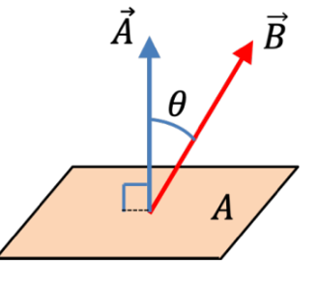
2. Larger flux when B larger
3. Higher density of lines symbolizes high magnetic field
4. You can also catch more field lines by making the area A larger
5. Angle Theta between magnetic field and area
6. If the field lines do not go straight into the area, you get less flux
7. Large flux 🡪 theta is approximately 0 degrees
8. Zero flux indicates that no lines go through the area 🡪 theta is approximately 90 degrees
9. We assign directions to a flat area
10. The normal vector A is always perpendicular to the area
11. 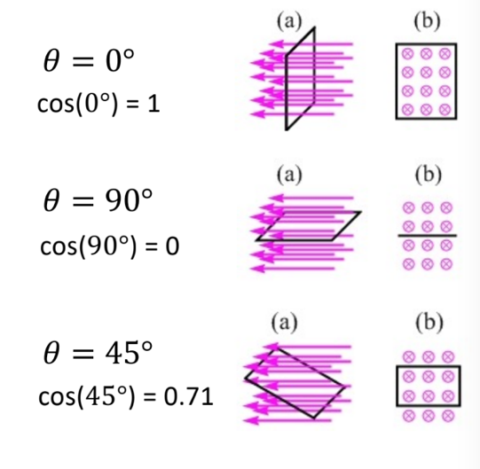
12. Which area has biggest flux?
13. Four different regions in the magnetic field.
14. The field has the same magnitude everywhere but it is directed into the page in the left half of the field and out of the page in the right half
15. 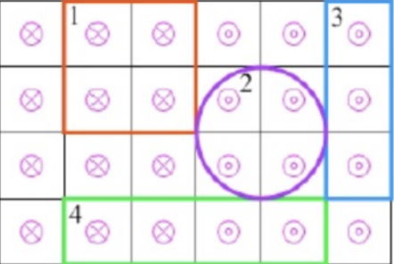
16. Area 1
17. Magnetic Flux Comparison
18. Which loop has larger flux?
19. 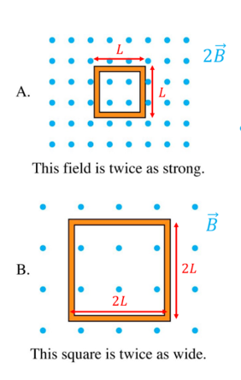
20. Loop B has larger flux 🡪 Ob=B\*2L\*2L = 4BL^2 while Oa=2B\*L\*L = 2BL^2
21. Magnetic Flux, O
22. Another clever way to increase magnetic flux 🡪 multiple loops
23. 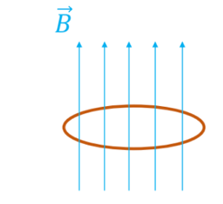
24. Magnetic flux for a single loop of area A
25. O = BA\*cos(theta)
26. 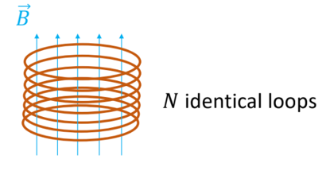
27. Magnetic flux for N identical loops of area A
28. N\*O = N\* BA\*cos(theta)
29. Faraday’s Law of induction
30. What we learned about magnetism:

* Moving charges in magnetic field feel a force
* Moving charges (currents) generate a magnetic field

1. You can create an Emf (voltage) in a conducting loop, simply by moving a magnet… if you complete the circuit, there’s a current
2. A changing magnetic flux will generate a voltage (emf) Ɛ in a coil of N turns given by:

Ɛ = -N \* delta(O) / delta(t) where O equals BAcos(theta)

1. 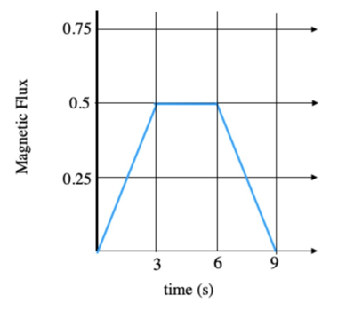
2. 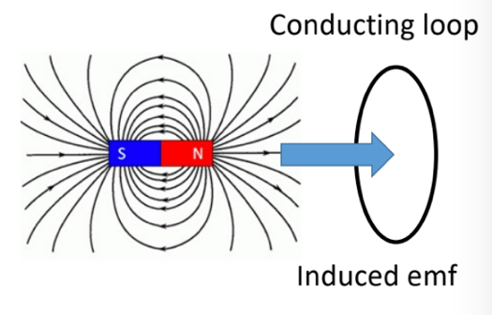
3. Faraday’s Law Examples
4. 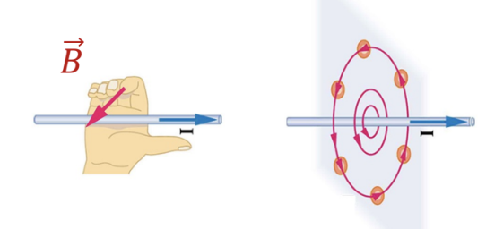
5. Above the wire, the field lines are coming out of the page
6. Below the wire, the field lines are going into the page
7. 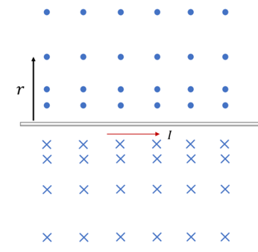
8. Notice how dots and x’s are spaced farther apart when we move farther away from the wire (indicating magnetic field strength)
9. 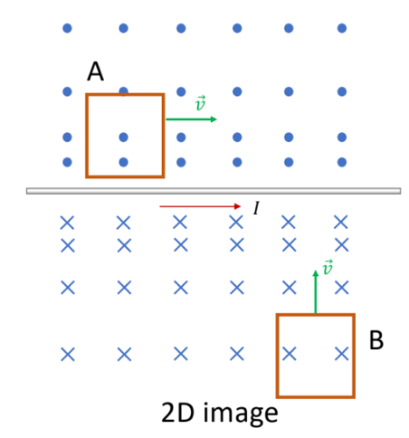
10. Two rectangular loops are moving in some direction through the magnetic field of a current carrying wire. In which loop will the magnetic flux increase over time
11. Loop B moves closer to the wire, and the magnetic field gets stronger over time:

Ɛ = -N \* delta(B) / delta(t) \* A \* cos(theta)

1. Graphs and Faraday’s Law of induction
2. A graph of magnetic flux through a circular coil is plotted as a function of time. The coil has 5 turns (loops). What dos this graph tell us about the induced emf, Ɛ?
3. 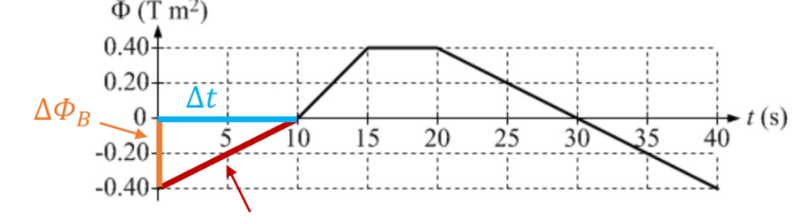
4. Ex) Consider the period of 0 to 10 seconds; this is a straight line with a positive slope

Ɛ = -N \* delta(O) / delta (t) = -5 \* (0.4/10) = -0.20V

1. Assuming the coil has a total resistance of 10 ohms, if we complete the circuit, what is the induced current in the coil between 0 – 10 seconds?

Ɛ = Iind\*R

0.20V = Iind\*10 Ohms

Iind= 0.20V / 10 Ohms = 0.02A